**Topographic Survey of Community Secondary School Elekahia, Port Harcourt Local Government Area of Rivers State, Nigeria.**

NSIRIM, Chika Hope  
**DE. 2019/1952**

**September, 2024**

**Topographic Survey of Community Secondary School Elekahia, Port Harcourt Local Government Area of Rivers State, Nigeria.**

**By**

NSIRIM, Chika Hope  
**DE. 2019/1952**

**A Project work Submitted to the Department of Surveying and Geomatics, Faculty of Environmental Sciences, Rivers State University, Nkpolu, Oroworukwo Port Harcourt, in Partial Fulfilment of the Requirements for the Award of Bachelor of Technology (B.Tech) Degree in Surveying and Geomatics.**

Surv. Durojaiye Adebanjo

**Supervisor**

**September, 2024**

Declaration

I hereby declare that this project work submitted to the Department of Surveying and Geomatics, Faculty of Environmental Sciences, Rivers State University; is the original work and it has not been submitted to this university or any other university for the award of any degree program.

_____________________________ __________________________

**NSIRIM, Chika Hope Date**

**Student**

Certification

This is to certify that this project work was carried out and submitted by **NSIRIM, Chika Hope (DE. 2019/1952)**, to the Department of Surveying and Geomatics, Rivers State University, Nkpolu-Oroworukwo, Port Harcourt, and is accepted as meeting the requirement for the award of Bachelor of Technology (B.Tech) Degree in Surveying and Geomatics.

________________________ _______________________

**NSIRIM, Chika Hope Date**

Student

________________________ _______________________

**Surv. Durojaiye Adebanjo Date**

Supervisor

________________________ _______________________

**Surv. Durojaiye Adebanjo Date**

Project Coordinator

________________________ _______________________

**Dr. Kurotamuno Peace Jackson Date**

Head, Department of Surveying and Geomatics

________________________ _______________________

**External Examiner Date**

Dedication

I dedicate this project my late father, Chief Ephraim Nsirim Nwankwo for his love, advice and his contribution to the success of my undergraduate program in the department of Surveying and Geomatics, Rivers State University. Thank you for your advice and contribution in choosing this career path, your words of wisdom remain forever fresh in my heart.

Acknowledgement

I am deeply humbled and grateful to acknowledge the invaluable support of individuals who helped transform my ideas into a tangible reality. Firstly, I extend heartfelt gratitude to my project supervisor, Surv. Durojaye Adebanjo, for his expert guidance throughout this project.

I also appreciate the unwavering support of my family: my late father, Chief Ephraim Nsirim Nwankwo; my mother, Mrs. Nuate Baridi Nwankwo; and my siblings - Dr. Nsirim Ovunda Precious, Dr. Nsirim Ichemadu Fortune, Nsirim B. Chima, Nsirim Treasure Ledum, and Nsirim Excellence. Special thanks to Awodu Apaovie Izu, Prince Golden Iheanacho, Victor Ohia, Isreal Woko Saviour and Surveyor Kingsley for their significant contributions.

I acknowledge the mentorship of Dr. Kurotamuno Peace Jackson, Head of the Surveying and Geomatics Department at Rivers State University. His tutelage and encouragement have been instrumental in my academic growth. I appreciate the lecturers of Surveying and Geomatics, including Dr. Lawrence Hart, Surv. Eze Promise Ikenda, Surv. G.T. Pepple, Surv. Tamunokuro Amos Opuaji, Surv. Eke Stanley Nwaudo, Surv. Tamunobelema Oba, Surv. Amina, Surv. Iyowuna Jonah, Dr. Okwerre Anwuri, and also the entire non-academic staff of the department for their valuable guidance helped me greatly.

Lastly, I thank God Almighty, my source of inspiration, without whom, none of this would have been possible."

Abstract

Topographic Surveying is done to depict the continuous configuration of the Earth's surface, the data derived from topographic surveys provides detailed and precise insights that are of paramount importance in mitigating risks and averting potential challenges in construction projects. Elekahia Community Secondary School is facing a persistent issue of water stagnation and this problem has given rise to a host of intricate challenges within the study area. Firstly, the accumulation of water has unintentionally transformed a significant portion of the school grounds into a catchment area. Consequently, this area is highly vulnerable to flooding and erosion during heavy rainfall, leading to the deterioration and damage of crucial school assets. Classrooms, in particular, have been abandoned due to this issue. Moreover, these seasonal floods disrupt academic activities, causing significant disturbances to the learning environment. Therefore the study aimed at carrying out topographic survey at Elekahia Community Secondary School, Port Harcourt Local Government Area of Rivers State. The classical method of data acquisition was deployed using Sokkia Total Station, the extent of the study area was determined using the method of loop traversing; the traverse had 9 turning points with a closing error of 0.054 and 0.062 for departure and latitude respectively and a linear misclosure of 0.082m, an angular misclosure of - 000 00′ 45″ and linear accuracy of 1:11329. The position of natural and man-made features within the study area was determined, as well as the elevation of the study area using Leica levelling instrument and topographic map of the study area was produced on a scale of 1:1000. The study revealed that the extent of the study area is 72893.049square meters, equivalent to 7 hectares and approximately 156 plots of land (Each plot is measured at 30.48m by 15.24m (464.515m2)), and a perimeter of 929.033. The study reveals that farms occupy the greatest extent, covering 50% of the study area, followed by open spaces, which account for 27%, and open fields, occupying 12%. Buildings cover 11% of the area, while septic tanks have the smallest occupancy within the study area. The study recommends that Efforts should be made to protect and restore the deteriorated school assets affected by water stagnation and a system should be established for ongoing monitoring and maintenance of flood control measures.

Table of Content

Cover Page

Title Page i

Declaration i

Certification ii

Dedication iii

Acknowledgement iv

Abstract v

Table of Content vi

Chapter 1: Introduction 1

1.1 Background to the Study 1

1.2 Statement of the Problem 3

1.3 Aim of the Study 4

1.4 Objectives of the Study 4

1.5 Study Area 5

1.6 Scope of the study 5

1.7 Significance of the Study 6

1.8 Definition of Terms 7

Chapter 2: Literature Review 8

2.1 Review of Related Literatures 8

2.2 Theoretical Framework 11

2.3 The Concept of Surveying 11

2.3.1 Primary Divisions of Surveying 11

2.3.2 Classification of Surveys 13

2.3.3 Classification based on the purpose of the survey 14

2.3.4 Classification based on instruments used 14

2.3.5 Principle of Surveying 15

2.4 Traverse 16

2.4.1 Types of Traverses 17

2.4.2 Sources of Error in Traversing 19

2.4.3 Mistakes in Traversing 19

2.5 Types of Errors 19

2.7 Levelling 21

2.7.1 Special Terms Used in Levelling 21

**Chapter 3: Methodology** 23

3.1 Research Approach 23

3.2 Instrumentation 23

3.3 Project Design 25

3.4 Reconnaissance Survey 25

3.4.1 Field Reconnaissance 26

3.4.2 Monumentation and numbering 26

3.5 Instrument Test/Check 28

3.5.1 Collimation Test 28

3.5.2 Two Peg Test 29

3.6 Data Acquisition 31

3.6.1 Secondary Data Sources: 31

3.6.2 Primary Data Sources 31

3.7 Data Processing 33

3.7.1 The Bearing, Latitude and Departure of a Survey Line 33

3.7.2 Reverse Directions or Back Bearing 34

3.7.3 Departure and Latitude Closure Conditions 36

3.7.4 Booking and Reduction of Levelling Data 40

3.8 Data Analysis 42

3.8.1 Traverse Linear Misclosure and Relative Precision 42

**Chapter 4: Results Presentation** 45

4.1 Control Extension 45

4.2 Spatial Extent of the Study area 45

4.3 Detailing 46

4.4 Elevation Information 48

4.5 Findings and Discussion 49

**Chapter 5: Conclusion and Recommendations** 50

5.1 Conclusion 50

5.2 Recommendations 51

Appendices 55

List of Tables

**Table 3.1:** Software and Hardware selection 24

**Table 3.2:** Project Team 24

**Table 3.3:** Horizontal and Vertical Collimation Test 29

**Table 3.5:** Angular misclosure for closed loop traverse 44

**Table 4.1:** List of coordinates for three control stations established in the study area 45

**Table 4.2:** Spatial extent of Elekahia Community Secondary School, Port Harcourt 45

**Table 4.3:** A sample of spatial information of features within Elekahia Community Secondary School, Port Harcourt 46

**Table 4.4:** Spatial extent of various features in Elekahia Community Secondary School, Port Harcourt. 47

**Table 4.5:** A sample of spot height data for Elekahia Community Secondary School, Port Harcourt. 48

List of Figures

**Figure 2.1:** Types of Traverses 17

**Figure 3.1:** Flow chart of Project Design 25

**Figure 3.2:** Cross section of monument 26

**Figure 3.3:** Schematic diagram showing the collimation test observation procedure 28

**Figure 3.4:** Schematic diagram illustrating two peg test procedure 30

**Figure 3.5:** Bearing, latitude and departure of a survey line 33

**Figure 3.6:** Reverse direction or back-bearing of a survey line 34

**Figure 3.7:** Algebraic sign convention for latitude and departures 36

**Figure 3.8:** Linear misclosure of a typical closed loop traverse 42

Figure 4.1: Percentage occupancy of various features in Elekahia Community Secondary School, Port Harcourt 47

List of Plates

**Plate 1.1:** The deterioration of the foundation of classroom block in Elekahia Community Secondary School, Port Harcourt 4

**Plate 1.2:** Satellite imagery of Community Secondary School, Elekahia 5

**Plate 3.1:** Picture of the Property beacons within the school premises 27

# Chapter 1

**Introduction**

# Background to the Study

Surveying is the bedrock of any meaningful development as it is essential and needed for almost all developmental activities. In essence, no meaningful development is achieved without Surveying (Odo, Idhoko, Oha, Okoro and Okafor, 2015). Provision of structures, planning of towns and cities; management of hazardous natural events and human actions such as erosion, flooding, earthquakes and subsidence; coastal management; exploration and exploitation of minerals; sitting of industries; resources exploitation on the land and on the sea are dependent on land surveying (Geomatics) deliverables (Oriola, and Asonibare, 2011 in Odo, et al, 2015).

According to Ghilani and Wolf (2015), the field of Surveying is continually evolving to Geomatics Engineering due to the change in scope of the practice and this is because of the recent technological developments that have provided new tools for measuring or obtaining information. One of the aspect of Surveying and Geomatics that is very significant to civil engineering works is Topographic Surveying which is done to determine the continuous configuration of the earth’s surface or a portion of the earth’s surface. Topographic survey provides detailed, accurate information and comprehensive data that helps eliminate the risks and probability of failure once the construction project begins, it prevents unnecessary expenses and delays and also ensures there are no major setback during the construction phase ([www.gulftestinglab.com](http://www.gulftestinglab.com), 18/05/23).

Topography is the study of the land surface. In particular, it lays the underlying foundation of a landscape. For example, topography refers to mountains, valleys, rivers, or craters on the surface. The origin of topography comes from “topo” which indicates place or region while ‘graphy or graphic’ refers to picture or drawing, in this regards; Topography is the study of the shapes, forms and features of land surfaces or the arrangement of the natural/artificial physical features of a particular area ([www.gulftestinglab.com](http://www.gulftestinglab.com), 18/05/23). Elevation is the distinguishing factor for topographic maps, the narrow definition of topography is specific to the arrangement of landforms but in a broader sense, it incorporates natural and artificial features ([www.gisgeography.com](http://www.gisgeography.com), 19/05/23).

The topography of an area describes the surface characteristics of relief features of such area as depicted by hills, valleys and plains. It can be used to study and represent as a surface, any characteristic that has a continuously changing value other than elevation. Topographic surveying involves the acquisition of topographic data of the features on the earth‘s surface, both man-made and natural in three-dimension (Northings, Eastings and elevation). This employs the techniques of plane surveying and other special techniques to establish horizontal and vertical controls. The implications of the above is that no meaningful development can be embarked upon by an individual, government and any other agencies without information about the topography of the area where such development is to take place (Odo, et al, 2015).

Mapping is one of the essential aspect of Geomatics and mapping surveys are made to determine the locations of natural and cultural features on the Earth’s surface and to define the configuration (relief) of that surface, once located, these features can be represented on maps. Natural features normally shown on maps include vegetation, rivers, lakes, oceans, etc. Cultural (artificial) features are the products of people, and include roads, railroads, buildings, bridges, canals, boundary lines, etc. The relief of the Earth includes its hills, valleys, plains, and other surface irregularities. There are two different types of maps; planimetric and topographic map and they are prepared as a result of mapping surveys. Topographic maps also include planimetric features, but in addition they show the configuration of the Earth’s surface. Both types of maps have many applications; they are used by engineers and planners to determine the most desirable and economical locations of highways, railroads, canals, pipelines, transmission lines, reservoirs, and other facilities; by geologists to investigate mineral, oil, water, and other resources; by foresters to locate access or haul-roads, fire-control routes, and observation towers; by architects in housing and landscape design; by agriculturists in soil conservation work; and by archeologists, geographers, and scientists in numerous fields (Ghilani and Wolf, 2015).

Acquiring topographic information at Elekahia Community Secondary School is essential due to the ongoing problem of water stagnation during heavy rainfall. This necessity stems from the critical need for informed decision-making regarding the area's development. Conducting a topographic survey will offer invaluable insights into the terrain's unique characteristics. This information will not only help address the immediate issue of water stagnation but also serve as a foundation for sustainable development initiatives within the school premises. Comprehensive topographic data will empower stakeholders to make informed decisions, ensuring that future infrastructure developments are strategically planned and resilient to environmental factors. Consequently, this will enhance the overall quality and safety of the school environment.

# Statement of the Problem

The Elekahia Community Secondary School is facing a persistent issue of water stagnation, this problem has given rise to a host of intricate challenges within the study area. Firstly, the accumulation of water has unintentionally transformed some part of the school surroundings into a catchment area. Consequently, this area is highly vulnerable to flooding and erosion (as shown in plate 1.1) during heavy rainfall, leading to the deterioration and damage of crucial school assets. Classrooms, in particular, have been abandoned due to this issue. Moreover, these seasonal floods disrupt academic activities, causing significant disturbances to the learning environment. Given the ongoing infrastructure development in the vicinity, it has become paramount to comprehensively address these challenges. This urgency led to the decision to acquire detailed topographic survey data, forming the bedrock for strategic flood control and mitigation efforts. This data will not only aid in resolving the current water stagnation problems but will also enable well-informed planning and construction of future structures within the school premises.

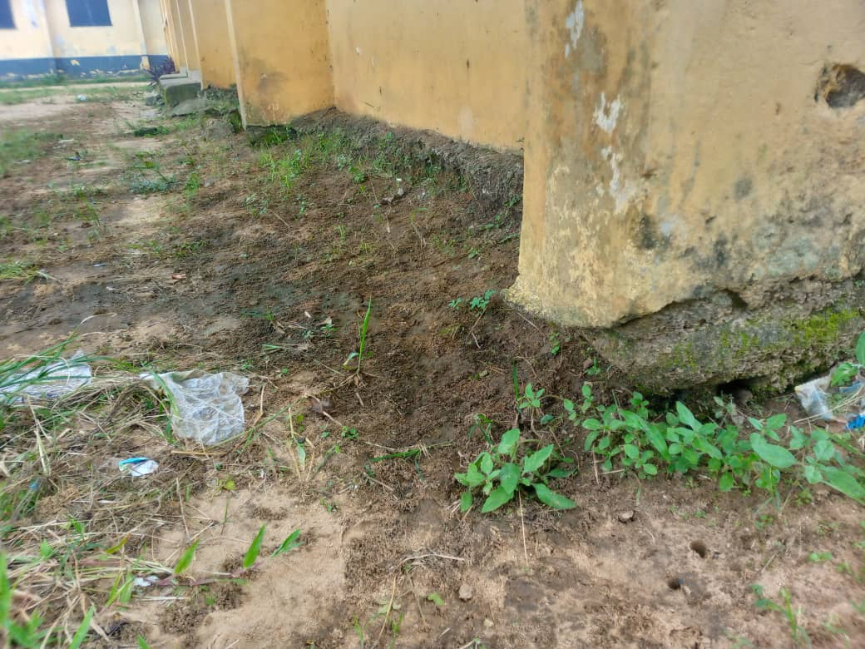

**Plate 1.1:** The deterioration of the foundation of classroom block in Elekahia Community Secondary School, Port Harcourt

**Source:** (Author;s field work, 2024)

# Aim of the Study

The aim of the study is to carry out a topographic survey of Community Secondary School Elekahia, Port Harcourt City Local Government Area of Rivers State, Nigeria.

# Objectives of the Study

The objectives of the study includes to:

1. Extend ground control stations within the study area.
2. Determine the extent of the study area.
3. Determine the relative position of manmade and natural features within the study area.
4. Determine the spot height of various points within the study area.
5. Produce topographic map of the study area.

# Study Area

Community Secondary School Elekahia is a mixed (boys and girls) school and is located in Elekahia Community, Port Harcourt Local Government Area of Rivers State. The school spatially located by the following projected coordinates; 532701.293mN, 280998.384mN and 532422.763mN, 281172.340mE of origin WGS 84 (World Geodetic System 1984) UTM zone 32N (Universal Transverse Mercator).

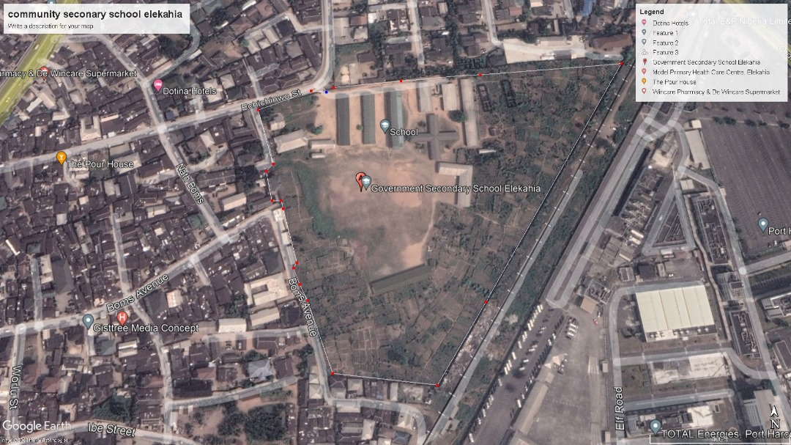

***Plate 1.2:*** *Satellite imagery of Community Secondary School, Elekahia*

***Source:*** *(Google Earth, 2024)*

# Scope of the study

The scope of this study is extensive, encompassing a thorough topographic survey that employs a range of methodologies to achieve its objectives. The process commences with a perimeter survey, utilizing the traversing field approach. This initial survey plays a pivotal role in establishing intermediary control stations strategically positioned within the study area. It's important to note that the presence of a concrete wall fence surrounding the study area renders traditional boundary traversing impractical. Instead, the study area's boundaries will be determined using the radiation method from these control stations.

The precise positions of both natural and man-made features within the study area will be determined with accuracy using the coordinate mode in a total station. This advanced technology ensures the collection of spatial data with a high degree of precision. Additionally, the vertical elevations of various points within the study area will be determined through the leveling method, providing valuable information about the terrain's height variations.

The ultimate outcome of this comprehensive survey will be the creation of a detailed topographic map. To accomplish this, cutting-edge software tools such as AutoCAD and Surfer will be employed. These software applications will facilitate the processing and visualization of the survey data collected, enabling the generation of a topographic map that faithfully represents the geographic features, elevations, and relative positions within the study area.

# Significance of the Study

This study stands to bring significant benefits to the following:

1. The researcher, who will gain valuable insights and expertise in acquiring, processing, and analyzing geospatial data for planimetric and topographic surveying and mapping, thereby enhancing greater knowledge and skills in this field.
2. The Rivers State Ministry of Education will benefit from the research findings by having access to crucial data to address the existing issue and prevent potential future damages of school infrastructure.
3. To the school management and students as it would ease the inconveniences often faced especially during the rainy season, if the work is being carried out.

# Definition of Terms

1. **Surveying:** is defined as the science, art, and technology of determining the relative positions of points above, on, or beneath the Earth’s surface or of establishing such points (Ghilani and Wolf, 2012).
2. **Control surveys** establish a network of horizontal and vertical monuments that serve as a reference framework for initiating other surveys.
3. **Topographic surveys** determine locations of natural and artificial features and elevations used in map making (Ghilani and Wolf, 2012).
4. **Traversing:** A traverse is a series of connected lines whose lengths and directions are measured in the field. The survey performed to evaluate such field measurements is known as traversing (Roy, 1999).
5. **Levelling:** is the procedure for determining differences in elevation between points that are some distance from each other.
6. **Elevation:** is the vertical distance above or below a reference datum **(**Kavanagh & Mastin, 2014).
7. **Maps:** are visual expressions of portions of the Earth’s surface. Features are depicted using various combinations of points, lines, and standard symbols (Ghilani and Wolf, 2012).

## Chapter 2

**Literature Review**

## Review of Related Literatures

In the research work titled "Topographic Information System of Federal School of Surveying, Oyo East Local Government, Oyo State, Nigeria," Ojiako and Jimoh (2017) aimed at addressing the absence of a Topographic Information System (TIS) for effective planning of the Federal School of Surveying. The primary goal was to develop a TIS as a valuable tool for enhancing the school's planning and land management. The research involved a combination of field and office reconnaissance activities to gain familiarity with the terrain and determine the appropriate methodology and equipment for acquiring and assembling both spatial and attribute data. Geometric (spatial) data were collected through ground survey methods employing a Total Station, encompassing processes such as traversing, detailing, and acquiring spot heights, which were executed simultaneously. The data processing phase was efficiently executed, employing tools such as Leica Geo Office Tools and South NTS Software for data downloading, Notepad and Microsoft Excel for editing and preprocessing, AutoCAD 2016 for drafting, Surfer 11 for generating a Digital Terrain Model (DTM) and 3D Wireframe Map, while ArcGIS 10.0 was utilized for spatial analysis, query generation, and information presentation. A model database was structured using a relational table format, enhancing data organization and accessibility. The resultant maps and queries provided essential support for decision-making processes, aiding professionals such as Land Surveyors, Architects, Engineers, Urban and Regional Planners in planning, designing, and executing crucial infrastructural projects within the school premises. As a key recommendation, the study underscores the importance of establishing TIS as a lasting tool for decision-making and land resource management to facilitate effective and sustainable development.

Eteje and Okpeahior (2021) in the research work, Determination of the Topography and Draining of the Site for the Benin City Bus Rapid Transit (BRT) Station, determines the topography and drains the site for the Benin City Bus Rapid Transit (BRT) station in Oredo Local Government Area of Edo State. A topographic survey was carried out to produce topographic plans. The accuracy of the survey was computed to determine its reliability. The perimeter survey plan was plotted using AutoCAD Civil 3D Land Desktop Companion 2009 to present the area, shape, perimeter and orientation of the site. The TIN method was used for the computation of the volume of earthworks. The existing and the finished ground surfaces, vector, as well as the flow direction plans, contour plans and the 3D surface maps were plotted using Surfer 11 to show graphically the existing and the proposed topography of the site. A network of drainages was established to drain the site. The study revealed that the site can be drained in two ways, into the moat behind it and existing drainage along Obakhavbaye.

Aminigbo (2021) in the research work, An Appraisal of a Detailed Perimeter Survey of Igwuruta Flood Plain in Greater Port Harcourt City of Rivers State’ aimed to ascertain the dimension of Igwuruta flood plain in greater portharcourt city of rivers state. The Perimeter and detail Survey was carried out at Igwuruta flood plain of greater Port Harcourt city of Rivers state. The survey was carried out in accordance with the third order specifications for a survey operation. The reconnaissance survey was properly carried out both in the office and on the field; this was carried out for proper planning of the survey operation by locating the controls needed for proper orientation. Data processing was done so as to reduce the data collected in the field and the necessary corrections were applied so as to obtain the corrected bearings and distances of points relative to one another. The corrected values were reckoned with in every aspect of computation and also in plotting the plan. The final plan was produced showing the boundary of the traverse, the bearings and distances and also the details found within the site.

The need for the production of Topographic Information System (TIS) of Federal School of Surveying, Oyo arose due to the absence of Topographic Information System for proper planning of the school. Therefore, TIS was carried out with the aim of producing a tool for effective planning and land management of the school. Field and Office reconnaissance were carried out in order to be familiar with the terrain and do proper planning on the methodology and equipment to be used for the acquisition and assembling of spatial and attribute data. The geometric (spatial) data were acquired by ground survey method using Total station (South S74301) through the process of traversing, detailing and obtaining spot heights which were carried out simultaneously. The data processing were adequately and effectively done using Leica Geo Office Tools and South NTS Software for Data downloading, Notepad and Microsoft Excel for editing and preprocessing, AutoCAD 2016 for draughting, Surfer 11 for generating the Digital Terrain Model (DTM) and 3D Wireframe Map while ArcGIS 10.0 version was used for spatial analysis, query generation and information presentation. A model database was created and structured using the relational table format. The interpretation of the maps and queries produced, supports decision making policy needed by the Land surveyors, Architects, Engineers, Urban and Regional planners to plan, design and execute vital infrastructural projects in the school. It was recommended that TIS should become a lasting tool for decision making and management of land and its resources for effective and sustainable development.

Gade (2022) carried out topographic survey at Rivers state University Ahoada campus. The study used the methods of traversing and leveling for data acquisition. The study revealed that the total area surveyed was 99317.465.sq.mtrs, having a perimeter of 1472.0503m. Levelling was carried out on a grid interval of 10m with a total of 200 spot height. The linear misclosure obtained in Eastings was -0.0Im and -0.00Im for Northings with a linear accuracy of 1:91,000. A topographic map of the area was produced using scale of 1:2000.

## Theoretical Framework

As stated by Danbuzu, Tanko, Ibrahim, and Ahmed (2014), a theory serves as an idea employed to explain a situation or justify a specific course of action. The purpose of theories lies in their ability to explain, predict, and enhance understanding of a phenomenon. In the context of this research work, there are several relevant theories that can be applied to bolster and enrich one's comprehension of the subject matter.

## The Concept of Surveying

Surveying may be defined as the science of determining the position, in three dimensions, of natural and man-made features on or beneath the surface of the Earth (Schofield and Breach, 2007). Surveying, which has recently also been interchangeably called geomatics has traditionally been defined as the science, art, and technology of determining the relative positions of points above, on, or beneath the Earth’s surface, or of establishing such points. In a more general sense, however, surveying (geomatics) can be regarded as that discipline which encompasses all methods for measuring and collecting information about the physical earth and our environment, processing that information. (Ghilani and Wolf, 2012).

Satell ites using GNSS receivers, or the use of satellite images for mapping and monitoring large regions of the Earth (Ghilani & Wolf, 2012).

## Primary Divisions of Surveying

The surveying may primarily be divided into two divisions:

1. Plane surveying,
2. Geodetic surveying

**Plane Surveying:** The surveys in which earth surface is assumed as a plane and the curvature of the earth is ignored, are known as Plane surveys. As the plane survey extends only over small areas, the lines connecting any two points on the surface of the earth, are treated as straight lines and the angles between these lines are taken as plane angles. Hence, in dealing with plane surveys, plane geometry and trigonometry are only required. Surveys covering an area up to 260 sq. km may be treated as plane surveys because the difference in length between the arc and its subtended chord on the earth surface for a distance of 18.2 km, is only 0.1 m. Scope and Use of Plane Surveying. Plane surveys which generally cover areas up to 260 sq. km, are carried out for engineering projects on sufficiently large scale to determine relative positions of individual features of the earth surface. Plane surveys are used for the lay-out of highways, railways, canals, fixing boundary pillars, construction of bridges, factories etc. The scope and use of plane surveys is very wide. For majority of engineering projects, plane surveying is the first step to execute them. For proper, economical and accurate planning of projects, plane surveys are basically needed and their practical significance cannot be over-estimated (Agor, 1979).

**Goodetic Surveying:** The surveys in which curvature of the earth is taken into account and higher degree of accuracy in linear as well as in angular observations is achieved, are known as ‘Geodetic Surveying’. In geodetic surveying, curvature of the earth’s surface is taken into account while making measurements on the earth’s surface. As the surveys extend over large areas, lines connecting any two points on the surface of the earth, are treated as arcs. For calculating their projected plan distances for the plotting on the maps, the curvature correction is applied to the measured distances. The angles between the curved lines are treated as spherical angles. A knowledge of spherical trigonometry is necessary for making measurements for the geodetic surveys.

**Scope and use of Geodetic Surveying:** Geodetic surveys are conducted with highest degree of accuracy to provide widely spaced control points on the earth’s surface for subsequent plane surveys. Provision of such control points, is based on the principle of surveying from the whole to the part and not from the part to the whole. Geodetic surveys require the use of sophisticated instruments, accurate methods of observations and their computation with accurate adjustment. These surveys are generally carried out to provide plan control. To eliminate the errors in observations due to atmospheric refraction, angular observation (Agor, 1979).

## Classification of Surveys

According to the use and the purpose of the final maps, surveys may be classified, under the classification based upon the nature of the field Land Surveys. These include the following:

**Topographic surveys:** The surveys which are carried out to depict the topography of the mountaineous terrain, rivers, water bodies, wooded areas and other cultural details such as roads, railways, townships etc., are called topographical surveys.

**Cadastral surveys:** The surveys which are generally plotted to a larger scale than topographical surveys and arc carried out for fixing the property lines, calculation of area of landed properties and preparation of revenue maps of states, are called cadastral survey. These are also sometimes used for surveying the boundaries of municipalities, corporations and cantonments (Agor, 1979).

**City surveys:** The surveys which are carried out for the construction of roads, parks, water supply system, sewer and other constructional work for any developing township, are called City surveys. The city maps which are prepared for the tourists are known as Guide Maps. Guide maps for every important city of India, are available from the offices of the department of Tourism.

**Hydrographic Surveys:** The surveys which deal with the mapping of large water bodies for the purpose of navigation, construction of harbour works, prediction of tides and determination of mean sea-level, are called Hydrographic surveys. Hydrographic surveys consist of preparation of topographical maps of the shores and banks, by taking soundings and determining the depth of water at a number of places and ultimately surveying bathymetric contours under water.

**Astronomical Surveys:** The surveys which are carried out for determining the absolute locations i.e., latitudes of different places on the earth surface and the direction of any line on the surface of the earth by making observations to heavenly bodies, i.e., stars and sun, are called astronomical surveys. In nothern hemisphere, when night observations are preferred to, observations are usually made to the Polaris, i.e., the pole star (Agor, 1979).

## Classification based on the purpose of the survey

**Engineering Surveys:** The surveys which are carried out for determination of quantities or to afford sufficient data for designing engineering works, such as roads, reservoirs, sewage disposal, water supply, etc., are called Engineering Surveys.

**Military or Defence Surveys:** The surveys which are carried out for preparation of maps of the areas of Military importance, are called military surveys.

**Mine Surveys:** The surveys which are carried out for exploration of mineral wealths beneath the surface of the ground, i.e., coal, copper, gold, iron ores etc., are called Mine surveys.

**Geological Surveys:** The surveys which are carried out to ascertain the composition of the earth crust i.e., different stratas of rocks of the earth crust, are called Geological surveys (Agor, 1979).

**Archaelogical Surveys:** The surveys which are carried out to prepare maps of ancient culture i.e., antiquities, are called Archaelogical surveys.

## Classification based on instruments used

According to the instruments used and method of surveying, the surveys may also be classified as under:

1. Chain surveying
2. Compass surveying
3. Plane table surveying
4. Theodolite surveying
5. Tacheometric surveying
6. Triangulation surveying
7. Aerial surveying
8. Photogrammetric surveying

**Geographical Survey:** The following technical terms are generally used in surveying;

**Plan:** A plan is the graphical representation of the features on the earth surface or below the earth surface as projected on a horizontal plane. This may not necessarily show its geographical position on the globe. On a plan, horizontal distances and directions are generally shown.

**Map:** The representation of the earth surface on a small scale, is called a map. The map must show its geographical position on the globe. On a map the topography of the terrain, is depicted generally by contours, hachures and spot levels.

**Topographical map:** The maps which are on sufficiently large scale to enable the individual features shown on the map to be identified on the ground by their shapes and positions, are called topographical maps.

**Geographical maps:** The maps which are on such a small scale that the features shown on the map are suitably generalized and the map gives a picture of the country as a whole and not a strict representation of its individual features, are called Geographical maps

## Principle of Surveying

The fundamental principles upon which different methods of surveying are based, are very simple. These are stated as under:

**Working from the whole to the part:** The main principle of surveying whether plane or geodetic is to work from the whole to the part. To achieve this in actual practice, a sufficient number of primary control points, are established with higher precision in and around the area to be detail-surveyed. Minor control points in between the primary control points, are then established with less precise method. Further details are surveyed with the help of these minor control points by adopting any one of the survey methods. The main idea of working from the whole to the part is to prevent accumulation of errors and to localise minor errors within the frame work of the control points. On the other hand, if survey is carried out from the part to the whole, the errors would expand to greater magnitudes and the scale of the survey will be distorted beyond control. In general practice the area is divided into a number of large triangles and the positions of their vertices are surveyed with greater accuracy, using sophisticated instruments. These triangles are further divided into smaller triangles and their vertices are surveyed with lesser accuracy.

**Location of a point by measurement from two control points:** The control points are selected in the area and the distance between them, is measured accurately. The line is then plotted to a convenient scale on a drawing sheet. In case, the control points are co-ordinated, their locations may be plotted with the system of coordinates, i.e., cartesian or spherical. The location of the required point may then be plotted by making two measurements (Agor, 1979).

## Traverse

A traverse consists of an interconnected series of lines called courses, running between a series of points on the ground called traverse stations. A traverse survey is performed to measure both the distances between the stations and the angles between the courses, the traverse stations can serve as control points. From those points, many less precise measurements can be made to features that are to be located for mapping, without accumulating accidental errors (Nathanson, Lanzanfama & Kissam, 2011).

A traverse is a series of connected lines whose lengths and directions are measured in the field. The survey performed to evaluate such field measurements is known as traversing (Roy, 1999).

## Types of Traverses

There are two basic types of traverses and both originates at a point of known location

**Open Traverse:** An open traverse terminates at a point of unknown position (Roy, 1999). An open traverse neither forms a closed geometric figure nor does it end at a point of known position (as shown in Fig. 2.1c). It cannot be checked for error of closure and relative accurascy. Open traverses are not recommended, but they are sometimes used out of necessity. All open traverse measurements must be repeated to avoid blunders (Nathanson, Lanzanfama & Kissam, 2011).

***Fig. 2.1a:*** *Closed Traverse;**Link/Connecting Traverse*

**A**

**B**

**C**

**D**

**E**

**F**

**F’**

**A’**

**Known**

**Point**

**Known**

**Point**

***Fig. 2.1b:*** *Closed Traverse;**Loop Traverse*

**A**

**B**

**C**

**D**

**E**

**A**

**B**

**C**

**D**

**E**

**F**

***Fig. 2.1c:*** *Open Traverse*

***Figure 2.1:*** *Types of Traverses*

***Source:*** *(Roy, 1999)*

**Closed Traverse:** A closed traverse terminates at a point of known location, Figure 2.1b shows a traverse which covers a plot of land in the form ABCDEA; the traverse originates and terminates at the same point; therefore, a closed traverse is geometrically and mathematically closed. When a closed traverse originates and terminates at the same point and all the internal angles are measured, we can utilize the mathematical condition that sum of the internal angles of a closed traverse is (2n - 4) right angles where n is the number of sides while for external angle is (2n + 4) right angles. This affords a check on the accuracy of the measured angles. It is possible to calculate the closing error which gives an indication of the accuracy of measurements. There is however no check on the systematic errors of measured length and hence, systematic errors should be detected and eliminated. In case a traverse originates and closes on known points. There is check for both linear and angular measurements (Roy, 1999).

There are two types of closed traverses; loop traverses and link/connecting traverses

A Loop Traverse: starts and ends at the same point, forming a closed geometric figure called a polygon (as shown in Fig. 2.1b). For example; the boundary lines of a tract of land forms a loop traverse (Nathanson, Lanzanfama & Kissam, 2011).

**Link/Connecting Traverses:** A connecting traverse looks like an open traverse, except that it begins and ends at points (or lines) of known position and direction at each end of the traverse (as shown in Fig. 2.1a). A connecting traverse is closed in the sense that it can be checked mathematically for the error of closure and the relative accuracy of the survey. Connecting traverses are generally used for horizontal control in route surveys (Nathanson, Lanzanfama and Kissam, 2011). Therefore, link/connecting traverses are "geometrically open and mathematically closed" (Roy, 1999).

**Traversing is used;**

1. To determine existing boundary lines.
2. To calculate area within a boundary',
3. To establish control points for mapping and also for photogrammetric work,
4. To establish control points for calculating earth work quantities, and
5. For locating control points for railroads highways, and other construction work.

## Sources of Error in Traversing

Some sources of error in running a traverse are:

1. Poor selection of stations, resulting in bad sighting conditions caused by
2. Alternate sun and shadow,
3. Visibility of only the rod’s top,
4. Line of sight passing too close to the ground,
5. Lines that are too short, and
6. Sighting into the sun.
7. Errors in observations of angles and distances.
8. Failure to observe angles an equal number of times direct and reversed

## Mistakes in Traversing

Some mistakes in traversing are:

1. Occupying or sighting on the wrong station.
2. Incorrect orientation.
3. Confusing angles to the right and left.
4. Mistakes in note taking.
5. Misidentification of the sighted station (Ghilani and Wolf, 2012).

## Types of Errors

There are basically two types of errors as reported by (Kavanagh, 2005), they are:

1. Systematic Errors,
2. Random Errors

**Systematic Errors:** T­hese are those errors whose magnitude and algebraic sign can be determined. The fact that these errors can be determined allows the surveyor to eliminate them from the measurements and thus improve accuracy. An error due to the effects temperature on a steel tape is an example of a systematic error. If the temperature is known, the shortening or lengthening effects on a steel tape can be determined precisely.

The following list includes several examples of systematic errors:

1. Using incorrect temperature and/or pressure observations,
2. Not applying curvature and refraction constants,
3. Using incorrect instrument heights and/or target heights,
4. Using an incorrect prism offset,
5. Using an imperfectly adjusted instrument.

**The effect of these errors can be minimized by:**

1. Properly leveling the survey instrument and targets,
2. Balancing foresight and back-sight observations,
3. Entering the appropriate environmental correction factors in the data collector,
4. Entering the correct instrument heights, targets heights, and prism offset in the data collector,
5. Periodically calibrating the surveying equipment

**Random Errors:** These errors are associated with the skill and vigilance of the surveyor. Random (also known as accidental) errors are introduced into each measurement mainly because no Human being can perform perfectly. So random errors by their very nature, tend to cancel themselves; when surveyors are skilled and careful in measuring, random errors will be of little significance except for high-precision surveys. However, random errors resulting from unskilled or careless work do cause problems (Ghilani and Wolf, 2012).

## Levelling

The art of determining relative altitudes of points on the surface of the earth or beneath the surface of the earth, is called levelling. This branch of surveying deals with measurements in vertical planes. For the execution of engineering projects, such as railways, highways, canals, dams, water supply and sanitary schemes, it is very necessary to determine elevations of different points along the alignments of the proposed projects. Success of such projects, depends upon accurate determination of elevations. Levelling is employed to provide an accurate network of heights, covering the entire area of the project. Levelling is of prime importance to the engineers, both in acquiring necessary data for the design of the project and also during its execution (Agor, 1979).

Levelling is the art of determining the elevation of given points above or below a datum line or establishing in given points of required height above or below the datum line. It involves measurement in vertical plane. The principle of levelling lies in providing a horizontal line of sight and finding the vertical distances of the points above or below the line of sight. The line of sight is provided with a level and a graduated levelling staff is used for measuring the height of the line of sight above the staff positions (Roy, 1999).

## Special Terms Used in Levelling

**Instrument station:** The point where instrument is set up for observations, is called instrument station.

**Station:** The point where levelling staff is held, is called station. It is the point whose elevation is to be determined or the point that is to be established at a given elevation.

**Height of instrument (HI):** The elevation of the line of sight with respect to the assumed datum, is known as height of instrument. In levelling it does not mean the height of the telescope above the ground level where the level is set up.

**Back sight (BS):** The first sight taken on a levelling staff held at point of known elevation, is called back sight. It ascertains the amount by which the line of sight is above or below the elevation of the point. Back sight enables the surveyor to obtain the height of the instrument. **Fore sight (FS):** The sight taken on a levelling staff held at a point of unknown elevation to ascertain the amount by which the point is above or below the line of sight, is called a fore sight. Fore sight enables the surveyor to obtain the elevation of the point. It is also generally known as minus sight as the foresight reading is always subtracted from the height of the instrument (except when the staff is held inverted) to obtain the elevation.

**Change point (CP):** The point on which both the fore sight and back sight, are taken during the operation of levelling, is called a change point. Two sights are taken from two different instrument stations, a fore sight to ascertain the elevation of the point while a back sight is taken on the same point to establish the height of the instrument of the new setting of the level. The change point is always selected on a relatively permanent point.

**Intermediate sight (IS):** The fore sight taken on a levelling staff held at a point between two turning points, to determine the elevation of that point, is known as intermediate sight. It may be noted that for one setting of a level, there will be only a back sight and a fore sight but there can be a number of intermediate sights (Agor, 1979).

**Bench mark (B.M.):** A relatively permanent and fixed reference point of known elevation above the assumed datum, is called a bench mark (Agor, 1979). Bench mark is a relatively permanent point of reference whose Elevation with respect to some assumed datum is known. There are four types of bench mark

1. G.T.S (Great trigonometry survey)
2. Permanent benchmark
3. Arbitrary benchmark.
4. Temporary benchmark

### Chapter 3

**Methodology**

This chapter outlines the systematic approach undertaken for conducting the topographic survey of Elekahia Community Secondary School, Port Harcourt. The methodology provides a structured plan that ensures the research is conducted in a logical, organized manner, allowing the achievement of reliable and valid results in line with the set aims and objectives.

### Research Approach

The method employed in this research is a quantitative approach, focusing on the collection, measurement, and analysis of numerical data related to the topographic features of the study area. This approach is suitable as it allows for precise mapping and representation of the terrain using measurable data, which is essential for topographic surveys. The data required for this project includes elevation points, boundaries, and other relevant topographic details of the school. These data were obtained through field measurements using Total Station equipment. The selection of this method ensures accuracy and reliability in capturing the terrain's features, with measurements taken at specific intervals to capture variations in elevation and ground contour.

### Instrumentation

For the field survey, a Total Station and levelling instrument was employed to collect spatial and elevation data. The total station instrument combines the capabilities of electronic distance measurement (EDM) and angle measurement, providing precise data on the position and height of points within the study area. The use of this instrument allows for efficient data gathering over the entire school premises, ensuring comprehensive coverage of the topography.

**Table 3.1:** Software and Hardware selection

|  |  |  |
| --- | --- | --- |
| **S/N** | **Software** | **Hardware** |
| 1 | AutoCAD | Sokkia Total Station |
| 2 | Google earth | Glass Prism Reflector |
| 3 | Microsoft Word | Tripod |
| 4 | Microsoft Excel | Beacon/peg |
| 5 | Surfer | Laptop |
| 6 |  | Printer |
| 7 |  | Field Book |
| 8 |  | Calculator |
| 9 |  | Ranging poles |
| 10 |  | 100m steel tape |
| 11 |  | Hammer |
| 12 |  | Cutlasses |
| 13 |  | PPE such as Safety shoes, reflective vest |
| 14 |  | Kolida RTK |

**Table 3.2:** Project Team

|  |  |  |
| --- | --- | --- |
| **S/N** | **Names** | **Status** |
| 1 | Surv. Durojaiye Adebanjo | Supervisor |
| 2 | Ogbugo Chigbem Godwin | Student |
| 3 | Kpanuku Elijah | Student |
| 4 | Raleigh Toby | Student |
| 5 | Nsirim Chika | Student |

### Project Design

**Topographic Survey**

Data Acquisition

Primary Data

Secondary Data

Instrument

Test

Control

Extension

Detailing/ Levelling

Data Processing

Field Data Reduction

Data Analysis

Area

Computation

Expected Maximum angular misclosure

Traverse

Angular misclosure

Traverse precision

Reconnaissance

Survey

Forward/Backward Computation

**Results**

Loop

Traversing

/Radiation

**Figure 3.1:** Flow chart of Project Design

**Source:** (Author’s work, 2024).

### Reconnaissance Survey

Reconnaissance survey is an extensive study of the entire area where a topographical survey is to be executed. The purpose of carrying out a reconnaissance survey is to know the nature of the environment, to select suitable stations for inter-visibility. It is the first and most essential part in every surveying activity. It is a preliminary study of a project site prior to field observation. It is made up of two types, field reconnaissance and office reconnaissance

### Field Reconnaissance

This was conducted by moving round the project site with pen and paper, taking sketch and records of the natural and artificial features within the site, and the following were also carried out; Station selection, Monumentation and control extension.

**Station Selection:** In the selection of stations, the following steps were taken into consideration;

1. Stations were selected where instrument can easily be set up
2. Inter-visibility of adjacent stations were ensured
3. Station were established where there would be minimal disturbance.
4. Avoidance of too many stations to reduce observation and computational error

### Monumentation and numbering

Monumentation is the process of setting a permanent marker by a surveyor to mark or reference point on a property or land which is permanently marked or tagged with the certificate of the surveyor setting it. For this cause monumentation and numbering were done for the purpose of station ID.

18cm

*Physical Surface/ Terrain*

*Beacon*

*Underneath Terrain*

**Figure 3.2:** Cross section of monument

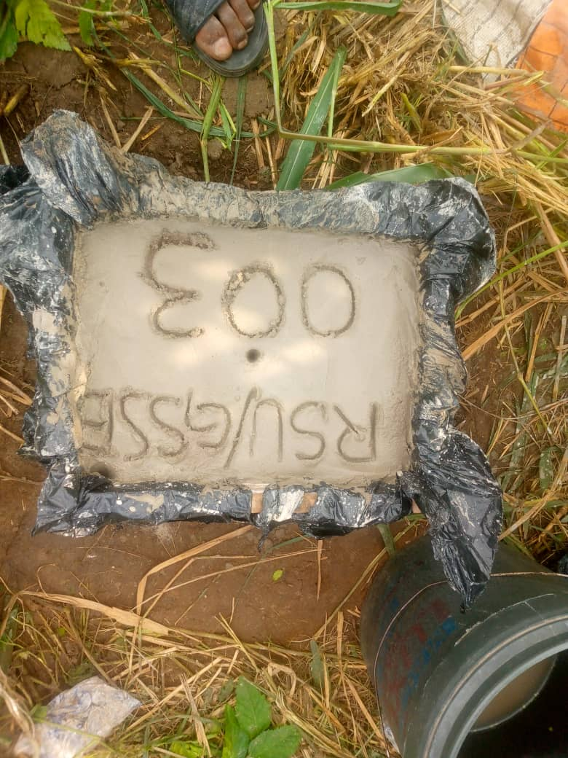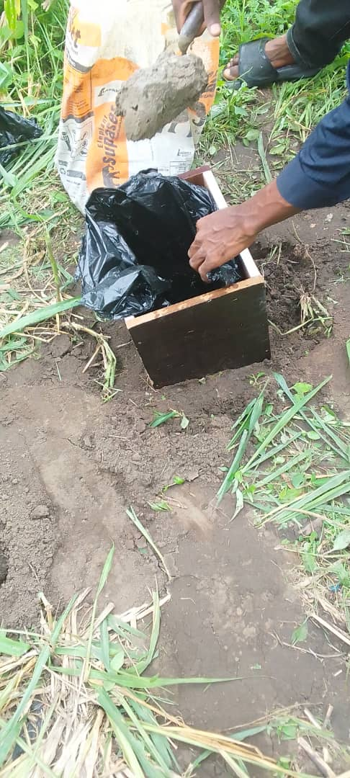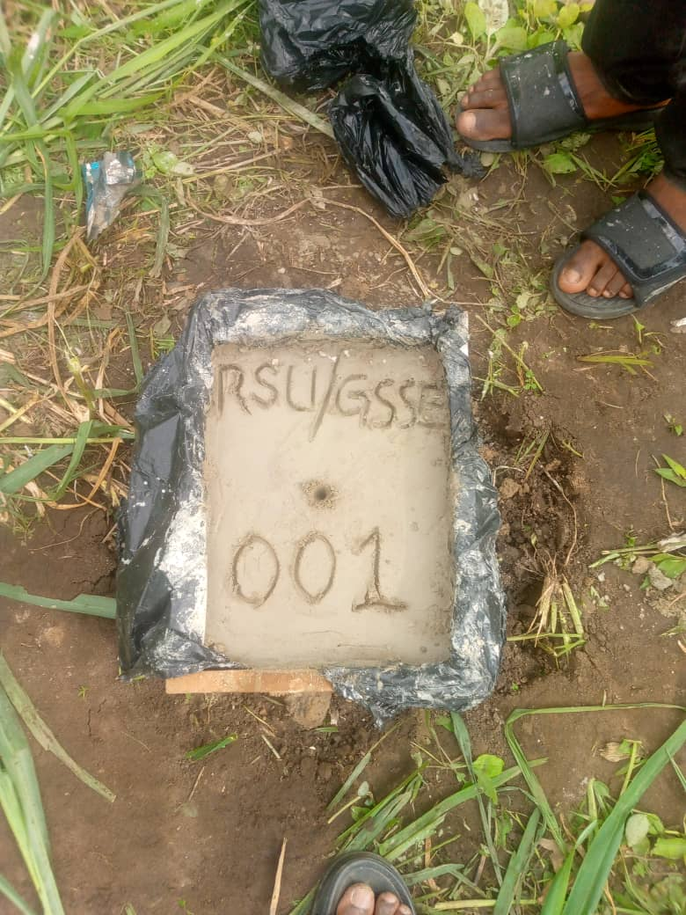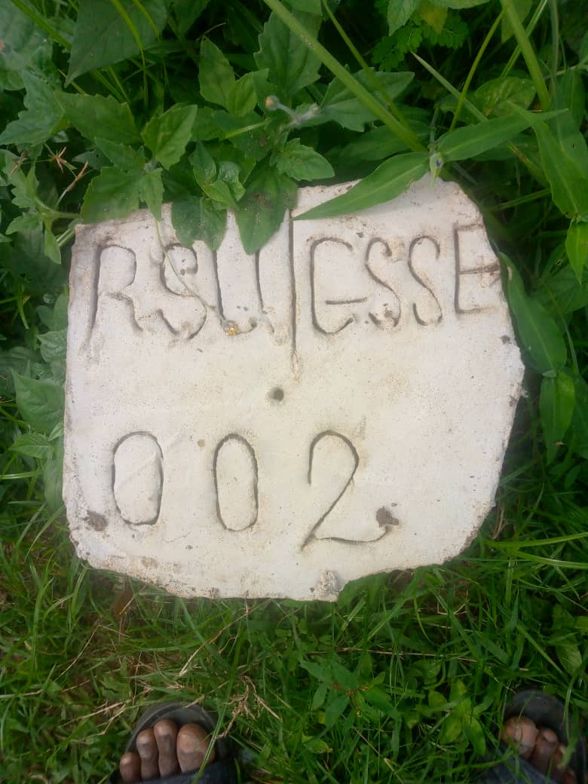

**Plate 3.1:** Picture of the Property beacons within the school premises

### Instrument Test/Check

In order to ascertain the reliability of the instrument, Collimation test was carried out on the instrument (Total Station);

### Collimation Test

This is the test carried out to ensure the line of sight is truly perpendicular to the horizontal axis of the telescope. When the collimation adjustment of an instrument is perfect (truly perpendicular to the horizontal axis), the error of collimation is zero ().

The collimation test is carried out for both the vertical and horizontal axis of the instrument.

**Horizontal collimation error:** it is theoretically known that the horizontal axis of the total station or theodolite is equal to but in practice, this theory is rarely achieved due to the sources of errors as explained in the previous chapter. Hence, the difference between the two faces reading (Face left and Face right) on same station should be (See Table 3.3).

**Vertical collimation test:** likewise, the vertical axis of the theodolite or total station is theoretically known to be equal to 360. Hence, the sum of the two face readings (Face left and Face right) on same station should be 360. (See Table 3.3)

Total Station test (collimation test)

*Line of sight*

*Total Station*

*Prism Reflector/*

*Ranging Pole*

*Physical Surface/ terrain*

***Figure 3.3:*** *Schematic diagram showing the collimation test observation procedure*

***Source:*** *Author’s Field work, 2024*

**Table 3.3:** Horizontal and Vertical Collimation Test

|  |  |  |  |  |
| --- | --- | --- | --- | --- |
| **Instrument Circle Reading** | **Face left** | **Face right** | **Error** | **Remark** |
| Horizontal Readings | 34 33´ 32″ | 33´ 08″ | 0 0´ 24″ | Allowable |
| Vertical Readings |  |  | -0 0´ 27″ | Allowable |

**Horizontal Collimation Test;**

**Vertical Collimation Test;**

**Remark;** Error is allowable/negligible as it deviates from by 24 for the horizontal axis and deviates from by 27 for the vertical axis.

### Two Peg Test

Verification of instrument accuracy is an essential task as all instruments are susceptible to errors. The primary source of error occurs when the line of sight deviates from being parallel to the horizontal line of collimation, leading to inaccuracies in the level. To assess and quantify such errors, a commonly employed test is the "two peg test," as illustrated in Fig. 3.3. This test serves to gauge the accuracy of the level by evaluating the parallelism of the line of sight with the horizontal plane. As shown in fig. 3.

*10m*

*20m*

*10m*

**A**

**B**

***1.542m***

***1.548m***

**FS**

**BS**

*5m*

*15m*

**B**

**A**

***1.572m***

***1.581m***

**FS**

*20m*

**BS**

***Figure 3.4:*** *Schematic diagram illustrating two peg test procedure*

***Source:*** *Author’s Field work, 2023*

Error = **Σ BS − Σ FS**

**Σ BS =** 1.542m + 1.581m = 3.123m

**Σ FS =** 1.548 + 1.572 = 3.120m

Error = **Σ BS − Σ FS =** 3.123m **−** 3.120m = **−** 0.003

**Check;**

**Difference of BS1 and FS1 - Difference of BS2 – FS2 = Error**

**Difference of 1st BS and FS =** 1.548 -1.542 = 0.006

**Difference of 2nd BS and FS =** 1.581 -1.572 = 0.009

**Error =** 0.006 - 0.009 = **−** 0.003

### Data Acquisition

### Secondary Data Sources:

Secondary Data are data relevant to this study that was obtained from existing work such as relevant related literatures and the coordinates of existing controls within the study area.

### Primary Data Sources

Primary Data are data obtained as a result of the researcher’s field work or observations. Spatial data were acquired using loop traversing method.

**Loop Traversing:** loop traverse starts and ends at the same point, forming a closed geometric figure called a polygon For example; the boundary lines of a tract of land forms a loop traverse. For this research work, loop traversing method was adopted to determine the extent of the study area.

The direction/progress of the loop traverse or survey which was in a clockwise direction therefore the angles deduced/reduced from the field observation/data were external angle. Field data were acquired using Sokkia Total Station with a glass prism reflector of 64mm diameter having and offset of 30mm (face)/0mm (back). The total station was mounted at each control/turning point or traverse leg. There were 21 control/turning points. At each turning point, the previous control point at the back line of the progress of the survey was referenced and then forwarded to the next turning point observing two faces (Face Left (FL) and Face Right) of the total station at each traverse leg. The survey started at GSSSE 001 and GSSSE 002 was referenced and two faces readings were taken and then forwarded to the next traverse leg; Peg 001 and two faces readings were also taken. This process was repeated at each traverse leg until all the 10 control/turning points were mounted on. To determine the boundary line. The technique of radiation was deployed where rays were forwarded to various visible points that delineates the boundary of the study area. A typical example of the field data booking is shown in appendix for field data/booking.

**Radial Method of Traversing:** Radiation method of traversing is an option adopted to carry out a perimeter survey where the instrument cannot be set up on the stations, as a result of fencing or any obstruction. It is done by establishing an auxiliary peg on a convenient point, where observations can be made to those points of interest. Therefore in carrying out the perimeter survey of this project radial method was adopted.

**Detailing:** this is the process of identifying and locating both natural and artificial features on the earth’s surface. It involves the extension of survey measurements to features with respect to already established frame work or a known line. For the purpose of this project subsidiary traverse points (stations) were established and coordinate mode was adopted to carry out the detailing operation.

**Field Procedure:** details were fixed by total station and reflectors using coordinate modules from the established subsidiary traverse stations. The procedure was applied to all other stations until all the details’ were fixed.

**Leveling:** the basic principle of leveling involves determining the height deference between points on the earth’s surface. Several methods can be adopted in leveling, but in the cause of carrying out this project; Grid leveling method was adopted.

**Gridding:** this is a process of taking blocks measurement of rectangles on the plan and transferring it to the ground with the use of measurement tape.

**Field procedure:** the benchmark RSU/GSSSE 002 was used as our benchmark for our leveling field data acquisition. Part of the school that were not flooded by water were gridded in a chainage of 10m interval, height of collimation method was used to reduce the height obtained from the field.

### Data Processing

Field data acquired during data acquisition were processed through the following computations or reductions.

1. Field data/Angle reduction
2. Traverse computation
3. Forward computation
4. Backward computation
5. Area computation using cross coordinate method

### The Bearing, Latitude and Departure of a Survey Line

X

LCos

**N**

Y Component

C

45

LSin

Departure of Line

**E**

X Component

B

**W**

**S**

Latitude of Line

***Figure 3.5:*** *Bearing, latitude and departure of a survey line*

***Source:*** *(Bhavikatti, 2010)*

The Bearing of a survey line is the direction of a survey line measured in a clockwise direction as referenced to the north-south meridian or direction. It is also the horizontal angle between true north or north-south meridian and the direction of the survey line measured in a clockwise direction (Bhavikatti, 2010). In figure 3.3; the Bearing of line XC is 45 which indicates the horizontal angle between the directions of the survey line as referenced to the north-south meridian. Likewise; the bearing of line XB is 300.

### Reverse Directions or Back Bearing

45

**N**

180

**C**

**N**

45

**X**

***Figure 3.6:*** *Reverse direction or back-bearing of a survey line*

***Source:*** *(Irvine, 1995)*

The forward bearing (FB) of the line XC in figure 3.4 is 45; however standing at point C and looking in the direction of point X, you would be looking in the reverse direction, therefore; the back bearing of the line CX would still be in a clockwise direction from the north point, N to the line CX, therefore; 45 which is the forward bearing of the line would be added to 180 which is the angular value from the direction of the north point, the back bearing would be 225. Therefore; we can utilize the mathematical condition or model for back bearing (BB);

BB = FB+180; however, if the forward bearing of a line is 225, adding 180 would be 405 which is more than 360 Subtracting 360 from 405 would be 45 which is similar to this condition;

BB = FB 180

+ 180 when FB < 180

* 180 when FB >180

The departure of a line is its orthographic projection on the east-west axis of the survey and is equal to the length of the line multiplied by the sine of its azimuth (or bearing) angle. Departures are sometimes called eastings or westings. Also as shown in Fig. 2.2, the latitude of a course is its orthographic projection on the north-south axis of the survey, and is equal to the length of the line multiplied by the cosine of its azimuth (or bearing) angle.

The Latitude of a line is also called northing or southing. The departure and latitude of a line are mathematically expressed as;

**Latitude** = LCos

**Departure** = LSin

Where L is the horizontal length and

is the bearing of the line.

Departures and latitudes are merely changes in the X and Y components of a line in a rectangular grid system, sometimes referred to as X and Y or E and N, change in eastings and northings or partial eastings and northings respectively. In traverse calculations, east departures and north latitudes are considered plus; west departures and south latitudes; minus (Ghilani and Wolf, 2012) as shown in figure 3.5.

**N**

**S**

-

**E +**

**-W**

**0**

**90**

**180**

**270**

**360**

+ 180

+ 180

+ 360

***1st Quadrant***

***2nd* Quadrant**

***3rd Quadrant***

***4th Quadrant***

**+**

***Figure 3.7:*** *Algebraic sign convention for latitude and departures*

***Source:*** *(Kavanagh and Mastin, 2014).*

### Departure and Latitude Closure Conditions

For a closed polygon or loop traverse, if all angles and distances were measured perfectly, the algebraic sum of the departures of all courses in the traverse should equal zero. Likewise, the algebraic sum of all latitudes should equal zero. And for closed link-type traverses like that of the algebraic sum of departures should equal the total difference in departure between the starting and ending control points. The same condition applies to latitudes in a link traverse. Because the observations are not perfect and errors exist in the angles and distances, the conditions just stated rarely occur. The amounts by which they fail to be met are termed departure misclosure and latitude misclosure. Their values are computed by algebraically summing the departures and latitudes, and comparing the totals to the required conditions. The magnitudes of the departure and latitude misclosures for closed polygon or loop traverses give an indication of the precision that exists in the observed angles and distances. Large misclosures certainly indicate that either significant errors or even mistakes exist. Small misclosures usually mean the observed data are precise and free of mistakes, but it is not a guarantee that systematic or compensating errors do not exist.

**Field data/Angle Reduction:** As mentioned earlier; two faces readings were observed at each turning point/traverse leg and was reduced to determine the angle using eqn. 3.1 below. Using the equation all the angles at the 10 stations were determined by reducing the field data.

FL2– FL1+FR1 – FR2

2

Angle Reduction = ***…..3.1***

**Traverse (Forward) Computation:** The summation of the whole processes of traverse forward computation are;

1. Computation of starting and closing bearings.
2. Calculation of angular misclosure by comparing the sum of the observed bearings with the closing bearing
3. Distributing the angular misclosure throughout the traverse in equal amounts to each angle depending if the misclosure is acceptable.
4. Computation of latitudes and departures of each survey lines.
5. Calculation of changes in coordinates of each traverse line.
6. Assessing the coordinate misclosure.
7. Balancing the traverse by distributing the coordinate misclosure throughout the traverse line.
8. Computation of the final coordinates of each point relative to the starting station.

From Fig. 3.2; the initial bearing of the traverse was determined by subtracting the coordinate of GSSSE 002 from GSSSE 001 to get the latitude and departure which was later substituted into eqn. 3.3 and also taking cognizance of its quadrant. The reverse direction/back bearing of the initial bearing was then determined by eqn 3.5; the bearing of the next survey line (GSSSE 001 to Peg 001) was determined by adding the initial back bearing (as determined from eqn. 3.6) to the observed angle at GSSSE 001. Hence; the whole process of the forward computation was done using the following mathematical expressions;

To obtain the initial bearing for traverse forward computation;

CIS – CBS = and

***…...3.2***

The bearing and distance can be gotten from the following mathematical models;

Distance = ***…...3.3***

tan-1 () + Q

Bearing = ***…...3.4***

BB = FB 180

***…...3.5***

+ 180 when FB < 180

* 180 when FB >180

180 or 360 should be added to the result gotten from eqn. 3.3 and it should be dependent on the quadrant the result obtained from the previous equation falls. In order to know the right quadrant for the result obtained from eqn. 3.3, the algebraic sign convention for departure and latitudes should be adopted by using the signs proceeding departure and latitude or partial eastings and northings; ∆E and ∆N respectively.

= FB - BB

***…...3.6***

= BB - FB

***…...3.7***

FB = BB

Where;

External angle

= Internal angle

FB = Forward Bearing

BB = Back Bearing

∆E = Partial Eastings (Departure)

∆N = Partial Northings (Latitude)

+ when is external (clockwise direction/progress of survey)

- when is internal (anticlockwise direction/progress of survey)

**Note:** In process of this computation, add 360 to any negative angle or bearing and any angle or bearing that is greater than 360 should be reduced by subtracting 360.

After correcting the bearing by dividing the difference between the initial and closing bearing by the number of stations and distributing the error by multiplying it sequentially by the number of stations; the latitude and departure of each line are determined.

Latitude = LCos

Departure= LSin

Where;

CIS = Coordinate of instrument station

CBS = Coordinate of back station

= Partial eastings/ change in eastings

= Partial northings/ change in northings

Q = Quadrant in which bearings fall

FB = Forward bearing

BB = Back bearing

= Angle

= Bearing

L = Length/distance of survey line

**Traverse (Backward) Computation:** After the coordinates have been corrected in the forward computed, the backward computation was done to get the corrected distances and bearings. In this computation, the algebraic sum of the latitudes and departures should be zero; this implies that the traverse is free of any linear and angular error of closure (see field data in appendix).

**Area Computation using Cross Coordinate Method**: Microsoft Excel was used to compute the area of the parcel using cross coordinate method from the coordinates obtained from backward computation which delineates the boundary/study area.

The area was computed using cross coordinate method as demonstrated below. The area of the study area was computed using the corrected coordinates by way of cross multiplying the northings and eastings sequentially. After taking the cross product of the coordinate, the algebraic sum of the products is taken for both northings-eastings (NE) product and eastings-northings (EN) product and then subtracted and divided by 2 neglecting the arithmetic sign. Hence, this can be mathematically expressed as;

**EN - NE**

**2**

**Area =**

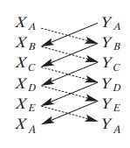

***…...3.8***

*coordinate method of area computation*

### Booking and Reduction of Levelling Data

Booking and reduction of the levels may be done by following two methods:

1. Rise and fall method.
2. Height of collimation method.

**Rise and Fall Method:** In this method, the difference of level between two consecutive points for each setting of the instrument, is obtained by comparing their staff readings. The difference between their staff readings indicates a rise if the back staff reading is more than the fore sight and a fall if it is less than the fore sight. The rise and fall worked out for all the points give the vertical distance of each point relative to the preceding one. If the RL of the back staff point is known, then RL of the following point may be obtained by adding its rise or subtracting its fall from the RL of preceding point.

**Arithmetic checks:** The difference between the sum of the back sights and the sum of the fore sights should be equal to the difference of the sum of rises and the sum of falls and should also be equal to the difference between the R.L. of the last point and that of the first point.

**Σ BS − Σ FS = Σ Rise − Σ Fall = Last RL − First RL**

**Height of Collimation Method:** In this method, height of the instrument (HI) is calculated for each setting of the instrument by adding the back sight (BS) to the elevation of the BM. The reduced level of the first station is obtained by subtracting its fore sight from the instrument height (HI). For the second setting of the instrument, the height of the instrument is calculated by adding the back sight taken on the first station to its reduced level. The reduced level of the last point is obtained by subtracting the fore sight of the last point from the height of instrument at the last setting. If an intermediate sight is observed to an intermediate station, its reduced level is obtained by subtracting its foresight from the height of the instrument for its setting. Summarily, this method uses this mathematical expression;

**HI = RL + BS**

**RL = HI – IS or FS**

**Arithmetic checks:** The difference between the sum of the back sights and the sum of the fore sights should equate to the difference between the RL of last station and the RL of the first station (Agor, 1979).

**Σ BS − Σ FS = Last RL − First RL**

### Data Analysis

The following analysis were carried out to ensure that the data acquired are within stipulated standard;

1. Expected maximum angular misclosure
2. Angular misclosure for loop traverse
3. Traverse precision

### Traverse Linear Misclosure and Relative Precision

**A**

**A’**

**C**

**D**

**B**

***Figure 3.8:*** *Linear misclosure of a typical closed loop traverse*

***Source:*** *(Ghilani and Wolf, 2012)*

Because of errors in the observed traverse angles and distances, if one were to begin at point A of a closed-polygon traverse like that of Figure 3.6 and progressively follow each course or line for its observed distance along its preliminary bearing or azimuth, one would finally return not to point A, but to some other nearby point A’. Point A’ would be removed from A in an east-west direction by the departure misclosure, and in a north-south direction by the latitude misclosure. The distance between A and A’ is termed the linear misclosure of the traverse. It is calculated from the following formula:

**Linear Misclosure** =

The relative precision of a traverse is expressed by a fraction that has the linear misclosure as its numerator and the traverse perimeter or total length as its denominator;

Linear Misclosure

Traverse Length

**Relative Precision** =

The fraction that results from Equation 2.4 is then reduced to reciprocal form, and the denominator rounded to the same number of significant figures as the numerator;

Linear Misclosure

Traverse Length

**Linear Accuracy** =

1

**Traverse precision:** The linear accuracy can be computed using the equation below;

931.470

1

Traverse Length

**Linear Accuracy** =

1

**Linear Accuracy =** **1:11329**

**Expected maximum angular misclosure:** For a third order traverse as shown in table 3.7; the expected maximum angular misclosure can be computed by this mathematical expression;

30″

***…...3.12***

***:*** *Maximum angular misclosure*

Where n = number of turning/control points, traverse legs or station.

Field data acquisition reveals that there are 21 turning points/stations that bounds the study area, hence; the maximum angular misclosure is; 30″ = 01′ 30″

**Angular misclosure for loop traverse:** a closed traverse is geometrically and mathematically closed. When a closed traverse originates and terminates at the same point and all the internal angles are measured, we can utilize the mathematical condition that sum of the internal angles of a closed traverse is; (2n - 4) 90

While for external angle is (2n + 4) 90

Where; n is the number of sides

This affords a check on the accuracy of the measured angles. It is possible to calculate the closing error which gives an indication of the accuracy of measurements.

The angles determine from the field observation are external angles, therefore eqn. 3.10 would be utilized;

(2n + 4) 90

(2 9 + 4) 90

24 90 = 1980 00′ 00″

Hence; the algebraic sum of all angles as observed on field should be 1980 00′ 00″ but no measurement is errorless so the value was rarely gotten after the summation of all angles gotten from our traverse operation; The algebraic sum of observed angles was; **1979 59′ 15″**

**Table 3.5:** Angular misclosure for closed loop traverse

|  |  |  |  |
| --- | --- | --- | --- |
| **Angular Misclosure** | | **Difference** | **Remark** |
| **Observed** | **Computed** |
| 1979 59′ 15″ | 1980 00′ 00″ | **-**000 00′ 45″ | Ok! |

#### Chapter 4

**Result presentation**

#### Control Extension

**Table 4.1:** List of coordinates for three control stations established in the study area

|  |  |  |  |  |
| --- | --- | --- | --- | --- |
| **S/N** | **Point ID** | **Eatings (m)** | **Northings (m)** | **Height (m)** |
| 1. | RSU/GSSSE 001 | 281044.5784 | 532629.9253 | 31.759 |
| 2. | RSU/GSSSE 002 | 281071.4221 | 532733.5112 | 33.640 |
| 3. | RSU/GSSSE 003 | 281008.8374 | 532706.1270 | 30.946 |

#### Spatial Extent of the Study area

**Table 4.2:** Spatial extent of Elekahia Community Secondary School, Port Harcourt

|  |  |  |
| --- | --- | --- |
| **Point ID** | **Northings (m)** | **Eastings (m)** |
| FPT 1 | 532721.039 | 281082.589 |
| FPT 2 | 532734.584 | 281196.601 |
| FPT 3 | 532742.261 | 281255.786 |
| FPT 4 | 532744.456 | 281377.979 |
| FPT 5 | 532724.401 | 281364.987 |
| FPT 6 | 532646.432 | 281316.356 |
| FPT 7 | 532560.673 | 281262.736 |
| FPT 8 | 532511.651 | 281231.403 |
| FPT 9 | 532461.126 | 281199.717 |
| FPT 10 | 532421.361 | 281175.083 |
| FPT 11 | 532424.527 | 281148.688 |
| FPT 12 | 532429.119 | 281109.431 |
| FPT 13 | 532432.888 | 281073.260 |
| FPT 14 | 532459.111 | 281066.368 |
| FPT 15 | 532491.526 | 281057.298 |
| FPT 16 | 532518.264 | 281049.857 |
| FPT 17 | 532573.045 | 281034.594 |
| FPT 18 | 532638.298 | 281016.575 |
| FPT 19 | 532664.528 | 281009.255 |
| FPT 20 | 532699.391 | 280999.461 |
| FPT 21 | 532705.439 | 281023.024 |
| FPT 1 | 532721.039 | 281082.589 |
|  | **Area =** | **72893.049** |
|  | **Hectare =** | **7.289** |
|  | **Plot =** | **156.923** |

#### Detailing

**Table 4.3:** A sample of spatial information of features within Elekahia Community Secondary School, Port Harcourt

|  |  |  |  |
| --- | --- | --- | --- |
| **S/N** | **Point ID** | **Northings (m)** | **Eastings (m)** |
| 1 | B | 532707.4038 | 281061.4619 |
| 2 | B1 | 532711.3375 | 281061.2534 |
| 3 | B2 | 532710.8829 | 281056.028 |
| 4 | B3 | 532707.126 | 281056.2624 |
| 5 | GATE | 532715.6448 | 281062.048 |
| 6 | GATE1 | 532717.1793 | 281067.8445 |
| 7 | B | 532691.0748 | 281022.796 |
| 8 | B1 | 532688.7175 | 281014.9268 |
| 9 | B2 | 532685.986 | 281014.8759 |
| 10 | B3 | 532683.789 | 281010.62 |
| 11 | B4 | 532674.547 | 281013.575 |
| 12 | B5 | 532678.5179 | 281026.7661 |
| 13 | B6 | 532665.9998 | 281015.8742 |
| 14 | B7 | 532649.448 | 281021.0908 |
| 15 | B8 | 532658.133 | 281050.1857 |
| 16 | B9 | 532662.8367 | 281049.4597 |
| 17 | B10 | 532663.9378 | 281051.2558 |
| 18 | B11 | 532670.8424 | 281049.3073 |
| 19 | B12 | 532670.1475 | 281046.6302 |
| 20 | B13 | 532675.1327 | 281044.9905 |
| 21 | B14 | 532661.6943 | 281054.6592 |
| 22 | B15 | 532653.0031 | 281054.8651 |
| 23 | B16 | 532653.0562 | 281065.6617 |
| 24 | B17 | 532648.5579 | 281065.4969 |
| 25 | B18 | 532648.0584 | 281055.5942 |
| 26 | B19 | 532643.3063 | 281055.5549 |
| 27 | B20 | 532644.1708 | 281068.0109 |
| 28 | B21 | 532652.6339 | 281068.3847 |
| 29 | B22 | 532653.4196 | 281077.5878 |
| 30 | B23 | 532662.2346 | 281077.2142 |

**Table 4.4:** Spatial extent of various features in Elekahia Community Secondary School, Port Harcourt.

|  |  |  |  |  |
| --- | --- | --- | --- | --- |
| **S/N** | **Features** | **Area (m2)** | **Hectare (m)** | **Plots** |
| 1. | Farm | 36709.660 | 3.671 | 79.028 |
| 2. | Open field | 8363.630 | 0.836 | 18.005 |
| 3. | Buildings | 7904.110 | 0.790 | 17.016 |
| 4. | Septic tank | 115.512 | 0.012 | 0.249 |
| 5. | Open Space | 19800.137 | 1.980 | 42.625 |
| **6.** | **Total** | **72893.049** | **7.289** | **156.923** |

**Figure 4.1:** Percentage occupancy of various features in Elekahia Community Secondary School, Port Harcourt

**Source:** (Author’s field work)

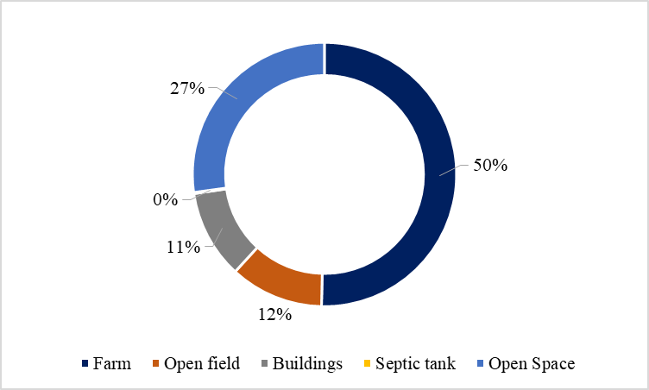

#### Elevation Information

Table 4.4 shows a specimen of spot height data of various points in the study area. The full list is in appendix 3. This result satisfies objective 4.

**Table 4.5:** A sample of spot height data for Elekahia Community Secondary School, Port Harcourt.

|  |  |  |  |  |
| --- | --- | --- | --- | --- |
| **Chainage** | **STN** | **BS** | **IS** | **FS** |
| 0.000 |  | 1.01 |  |  |
| 10.000 |  |  | 1.523 |  |
| 20.000 |  |  | 1.465 |  |
| 30.000 |  |  | 1.27 |  |
| 40.000 |  |  | 1.115 |  |
| 50.000 |  |  | 0.56 |  |
| 60.000 | CP | 2.8 |  | 0.26 |
| 70.000 |  |  | 1.575 |  |
| 80.000 |  |  | 1.473 |  |
| 90.000 |  |  | 1.168 |  |
| 100.000 |  |  | 0.55 |  |
| 110.000 |  |  | 1.359 |  |
| 120.000 |  |  | 1.52 |  |
| 130.000 |  |  | 1.362 |  |
| 140.000 |  |  | 1.45 |  |
| 150.000 |  |  | 1.645 |  |
| 160.000 |  |  | 1.805 |  |
| 170.000 |  |  | 2.03 |  |
| 180.000 | CP | 2.095 |  | 2.395 |
| 190.000 |  |  | 2.191 |  |
| 200.000 |  |  | 1.79 |  |
| 210.000 |  |  | 1.52 |  |
| 220.000 |  |  | 1.369 |  |
| 230.000 |  |  | 1.175 |  |
| 240.000 |  |  | 1.239 |  |
| 250.000 |  |  | 1.113 |  |
| 260.000 |  |  | 1.163 |  |
| 270.000 |  |  | 1.141 |  |
| 280.000 |  |  | 1.07 |  |
| 290.000 |  |  | 1.07 |  |
| 300.000 |  |  | 1.445 |  |
| 310.000 |  |  | 1.335 |  |
| 320.000 |  |  | 1.549 |  |
| 330.000 |  |  | 1.525 |  |
| 340.000 |  |  | 1.636 |  |
| 350.000 |  |  | 1.81 |  |
| 360.000 | CP | 1.372 |  | 2.285 |

#### Findings and Discussion

A topographic survey of the Elekahia Community Secondary School, Port Harcourt was conducted, with the findings presented through a series of tables and figures. Table 4.1 provides the coordinates of the control extension, while Table 4.2 outlines the extent of the study area, which spans 72,893.049 square meters, equivalent to 7 hectares or approximately 156 plots of land, with each plot measuring 30.48m by 15.24m (464.515m²) and a perimeter of 929.033m. Moving forward, Tables 4.3 and Figure 4.1 offer a detailed breakdown of the percentage occupancy for various features within the study area. Figure 4.1 reveals that farms occupy the greatest extent, covering 50% of the study area, followed by open spaces, which account for 27%, and open fields, occupying 12%. Buildings cover 11% of the area, while septic tanks have the smallest occupancy within the study area. Additionally, Table 4.4 provides valuable elevation data, which sheds light on the topography, continuous configuration, and terrain characteristics of the study area. This information adds a crucial layer to the understanding of the landscape, allowing for a more comprehensive interpretation of the survey results. The research findings and discussions presented in these tables and figures collectively contribute to a thorough exploration of the topography, offering detailed insights into the geographical features while serving as a valuable resource for future planning and development in the area.

##### Chapter 5

**Conclusion and Recommendation**

##### Conclusion

Due to the conversion of a sizable section of the school grounds into a catchment area, there is now a greater chance of erosion and floods, which has caused important school buildings, such classrooms, to deteriorate and be abandoned. This has further complicated the learning environment by significantly disrupting academic pursuits, especially during seasonal flooding. A thorough topographic survey was conducted to address these problems in the middle of current infrastructure construction, and the results provided vital information to help strategic efforts to mitigate and manage flooding. The survey's conclusions provide important information for addressing the current issues with water stagnation and for informing future building plans on the school grounds. By delineating the area's geographical features and attributes, the survey provides crucial data for urban planning, sustainable development and environmental management. Decision-makers can better direct future development initiatives by gaining important insights into the distribution of built-up and open spaces. Planning infrastructure, creating drainage systems, and maximizing land use all depend on having a solid grasp of the topography and its continuous configuration, which is provided by the elevation data. In addition to providing light on Elekahia Community Secondary School's problems with water stagnation, the topographic survey's findings give stakeholders the information and resources they need to manage flooding, plan land uses, and create infrastructure. These results emphasize how critical it is to deal with the current problems while building the school's resilience and sustainability.

##### Recommendations

The comprehensive topographic survey data will be essential in facilitating well-informed decision-making and enabling the adoption of practical measures to improve the resilience, functionality, and safety of the educational setting. As a result, the research suggests the following actions: Give the preservation and repair of school property that has suffered from water stagnation a priority. In order to prevent further harm, this may entail restoring damaged structures, moving facilities that are at risk, and putting preventive measures in place and   
to guarantee the long-term efficacy of flood control measures, put in place a mechanism for ongoing maintenance and monitoring.

References

Akintoye, O., Eyong, A., Agada, P., Digha, O., and Okibe, O., (2016). “Socio-Economic Implication of Nigeria Liquefied Natural Gas (NLNG) Project in Bonny Local Government Area, Rivers State, Nigeria.” Journal of Geoscience and Environment Protection, doi: [10.4236/gep.2016.45007](http://dx.doi.org/10.4236/gep.2016.45007).

Aminigbo, L., M., O., (2021). “An Appraisal of A Detailed Perimeter Survey of Igwuruta Flood Plain In Greater Portharcourt City of Rivers State”. International Journal of Information Systems and Informatics. Vol.2 No.4, e-ISSN 2746-1378.

Bhavikatti, S, S, (2010) “Surveying theory and practice”, I.K. International Publishing House Pvt. Ltd. New Delhi ISBN 978-93-80578-25-5

Danbuzu, L, A, S, Tanko, A, I, Ibrahim, U, A, and Ahmed, M, (2014). ‘Spatial Distribution of Solid Waste Collection Point using GIS Approach in Urban Katsina, Katsina State, Nigeria.’ American Journal of Engineering Research. Volume 3-issue 7, pp 107-116. ISSN 2320-0936

Didia, M., U., and Weje, I., I., (2020). “Effects Of Refuse Dump On Ground Water Quality Within The Rivers State University Campus, Port Harcourt, Nigeria”. International Journal of Scientific and Research Publications. , Volume 10, Issue 3, ISSN 2250-3153

Eteje, S., O., and Okpeahior A., C., “Determination of the Topography and Draining of the Site for the Benin City Bus Rapid Transit (BRT) Station”. Asian Journal of Advanced Research and Reports, vol 15(8): 48-63ISSN: 2582-3248.

Eteje, S., O., Ono, M., N., and Oduyebo O., F., (2018). “Monitoring and Analysis of Vertical Deformation of Palm House Benin City Using Digital Level”. International Journal of Advances in Scientific Research and Engineering, volume 4, issue 9. E-ISSN: 2454-8006.

Ghilani, C, D, and Wolf P, R, (2012). ‘Elementary Surveying, An Introduction to Geomatics; Thirteenth edition, Pearson Education Inc. New Jersey ISBN 13:978-0-13-255434-3.

Ghilani, D., C., and Wolf, P., R., (2015). “Elementary Surveying, an Introduction to Geomatics.” Pearson Education Inc. New York, ISBN: 978-0-13-375888-7

Irvine, W., (1995) “Surveying for construction”, McGraw-Hill Publishing Company, New Delhi ISBN 0-07-707998-1

Kavanagh, B, F and Mastin,T,B (2014). ‘Surveying Principles and Application; Ninth edition. Pearson Inc, New Jersey USA. ISBN 978-0-13-700940-4

Kavanagh, B., F., (2005), surveying principles and Application, Published by Pearson Education. ISBN: 0-13-118862-3

Nathanson, J., Lanzafama, .M, T., and Kissam, P., (2011). “Surveying Fundamentals and Practices” Pearson Education Inc. New Jersey United State of America ISBN-13:978-013-500037-3.

Odo, K., O., Idhoko, K., E., Oha., C., P., Okoro, E., G., and Okafor, C., E., (2015). “Topographic Information System as a Tool for Environmental Management, a Case of Part of Delta State Polytechnic, Ogwashi-uku Aniocha South, Delta State, Nigeria. Journal of Environmental Science, Vol 9(11) ISSN: 2319-2402.

Ojiako, J., C., and Jimoh, S., O., (2017). “Topographic Information System of Federal School of Surveying, Oyo East Local Government Oyo State Nigeria”. International Journal of Advanced Engineering, Management and Science (IJAEMS), vol-3, Issue-7, ISSN: 2454-1311.

Punmia, B., C., Ashok, K., and Jain, A., (2005), Surveying vol. 1, Published by Laxmi Publications (P) Ltd. ISBN: 81-7008-853-4

Roy, S, K, (1999). “Fundamentals of Surveying” Prentice Hall of India Private Limited, New Delhi ISBN81-203-1260-0.

Schofield, W, and Breach, M, (2007). “Engineering Surveying”, sixth edition. Elsevier Ltd. Barlington USA. ISBN-13:978-0-7506.

Uren, J, and Price, B, (2010). “Surveying for Engineers”, fifth Edition, published by Palgrave Macmillan Publishers. ISBN: 978-0-230-22157-4.

www.gisgeography.com (19/05/23). <https://gisgeography.com/what-is-topography>

www.gisgeography.com (19/05/23). <https://gisgeography.com/what-is-topography>

[www.gulftestinglab.com,(18/05/23)./https://gulftestinglab.com/topographical-survey-and-importance-of-topographical-surveys](http://www.gulftestinglab.com,(18/05/23)./https://gulftestinglab.com/topographical-survey-and-importance-of-topographical-surveys/)

[www.gulftestinglab.com,(18/05/23)./https://gulftestinglab.com/topographical-survey-and-importance-of-topographical-surveys](http://www.gulftestinglab.com,(18/05/23)./https://gulftestinglab.com/topographical-survey-and-importance-of-topographical-surveys/)

##### Appendices